Team Sirius: Science - Mrs. Stover

Welcome to 8th Grade and to Team Sirius. We are looking forward to a great year! Below you will find information about what you will need for class, how you will be graded, and what you will be studying this year in science class. Please refer to my school website to find additional information.

Classroom Information

Class Preparedness:
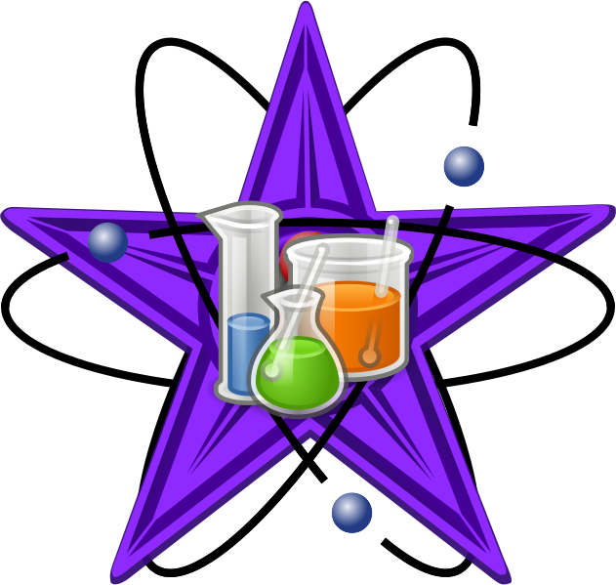
Students are responsible for coming to class prepared to learn. To this end students should always have the following items with them when they come to class.
- Science Binder (1 – 11/2" three-ring binder)
- iPad + ear buds
- Assignment Book
- Writing Utensils (pen/pencil/highlighter/stylus)
- Completed assignments when due

Class Procedures:
Many times during a class period we may be moving around to different locations in the classroom as well as outside the classroom. We will be doing a large number of hands-on labs and activities related to the 8th Grade Science curriculum. It is very important that my instructions are followed the first time to allow for smooth transitions between activities and more importantly to maintain a safe classroom environment.
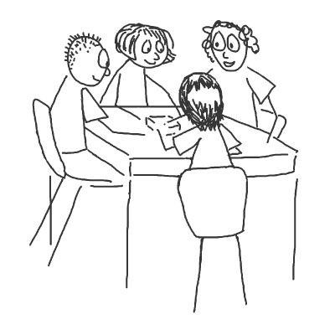
Classroom Expectations:
- Show up to class prepared and on time
- Be respectful to teacher and fellow students
- Be respectful to the property of others
- Follow directions the first time they are given
- Always try your best!

Grading Procedures

The grades for each marking period will be determined by a total points system. Students should have access to there grades via the Home Access Center. Grade percentages will be determined by dividing the number of points a student earns by the total number of points possible. The number of points per marking period will vary depending on the number of assignments given.

In the Home Access Center student assignments will be described as one of two types: Formative Assessment or Summative Assessment

Formative Assessment:
Formative assessments will be graded using a P, S, U scale. (P - Proficient, S - Satisfactory, U - Unsatisfactory) Formative assessments will NOT be factored into the letter grade students will earn for each marking period. They are mainly used as a tool to provide feedback to both teacher and student on the progress on a topic of study. Formative assessments will be given for each topic of study before summative assessments are administered.
Summative Assessment:
Summative assessments will be graded using a total points system. Each summative assessment will be worth a certain amount of points that will count toward the total points for marking period. The marking period grade will be determined by dividing the points earned on all summative assessments by the total points for the marking period. Most summative assessment points will come from unit quizzes and end-of-unit tests. Occasionally, lab activities and will be assigned a point value and therefore be graded as a summative assessment.

Assessment Retake Policy
Throughout the year, students will have the opportunity to retake unit quizzes if they choose to do so. Students will NOT have the opportunity to retake end-of-unit tests. In order to earn the privilege to retake a unit quiz students must complete all tasks listed on the Assessment Retake Information Sheet. A copy of the information sheet can be found on my website home page.

Course Overview

Below is schedule of the topics to be covered during the course of the school year. Individual lesson overviews can be found within each unit folder on my website.

Introduction to Science
- Observation vs. Inference
- Hypothesis, Theory, Scientific Law
- The Scientific Method
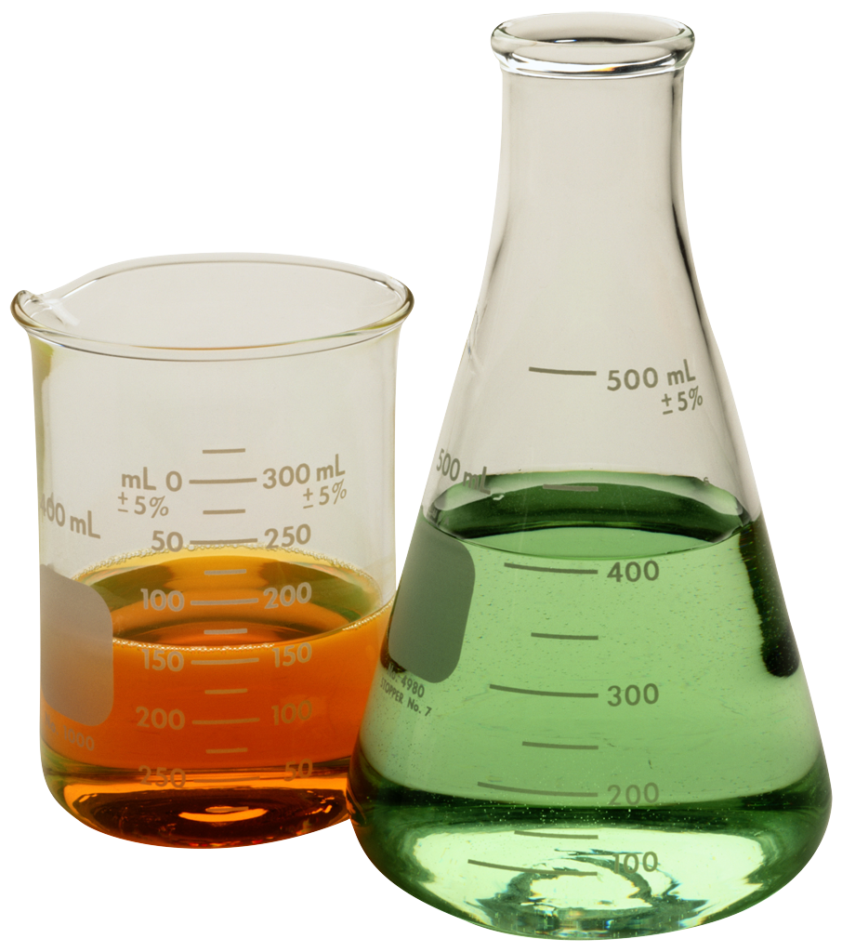
- Parts of an Experiment
- The Metric System
- Scientific Notation

Meteorology
- Weather vs. Climate
- Earth’s Atmosphere
- Heat Transfer in the Atmosphere
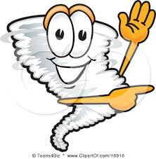
- Density
- Water in the Air
- The Water Cycle
- Air Pressure and Wind
- Air Masses
- Cold and Warm Fronts
- Reasons for the Seasons
- Earth, Moon Sun System
- Severe Weather

Genetics & Natural Selection
- Instinctive vs. Learned Behaviors
- Response to Environmental Changes
- Inherited vs Acquired Traits
- Genes
- Mutations

Energy
- Renewable and Non-renewable Energy
- Forms and Sources of Energy
- Methods of Energy Transfer
- Human impact on Environment

Electricity and Magnetism
- Energy Transfer through Electricity
- Electric Circuits
- Voltage, Current, and Resistance
- Magnets and Magnetic Fields

